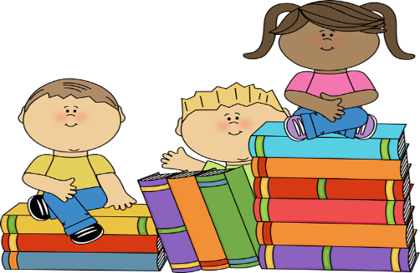

**School Supply List**

**Reading**

1 Composition Notebook (To stay in class)

The student will need to bring these items to class daily!

Pencils

Crayons

Color Pencils

Notebook Paper

Earbuds

***Wish List Items***

Boxes of facial tissues

Rolls of paper towels

Containers of Clorox wipes

Bottles of hand sanitizer

Extra Pencils

Extra Packs of Paper